**GAS LEAKAGE MONITORING AND ALERTING SYSTEM FOR INDUSTRIES**

**CIRCUIT DIAGRAM AND SCHEMATIC VIEW**

**TEAM ID:** PNT2022TMID11701

**CIRCUIT DIAGRAM:**

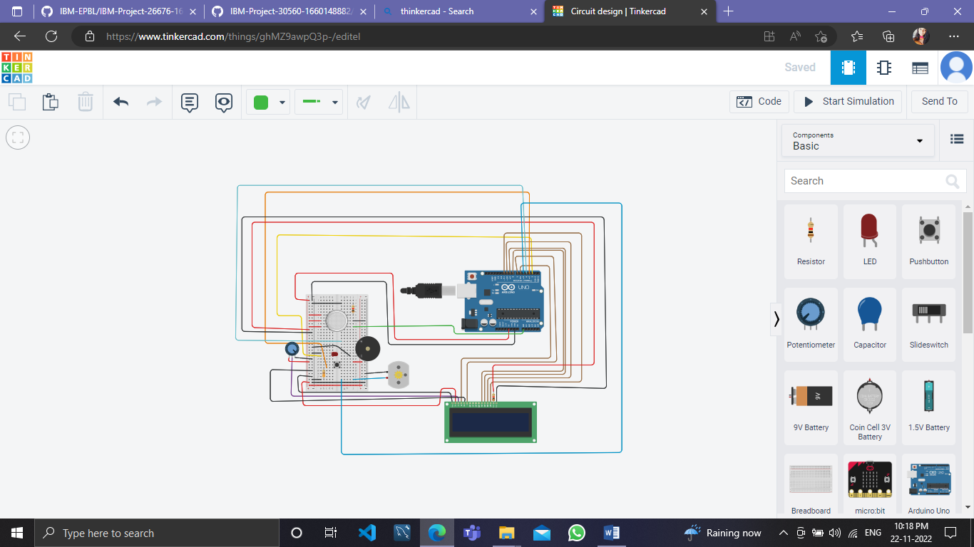

**SCHEMATIC DIAGRAM:**

